Minutes of the SUNFLOWER training session in Moura

22nd February
The session began with the welcoming speech of the Mayor of Moura, José Pós-de-Mina that greeted the students and enhanced the importance of the SUNFLOWER project and of this training in particular.
António Martins presented the SUNFLOWER project, emphasizing its main objectives.
Sandrina Pereira presented the objective of the training and exposed the sessions that would take place that week.
Maria Basílio, from the Polytechnic Institute of Beja, presented the fundamentals of a business plan and provided a budgeted balance sheet and a budgeted income statement of a firm for the students to fill. This was very important to involve the students in the session and consolidate their knowledge. The students were very participant and all tried to solve the exercise exposing questions when they had any doubt.

23rd February
This day was filled with the lecture from Fernando Teixeira, from the Polytechnic Institute of Beja.

24th February
This day started with a visit to the Alqueva’s hydroelectric power station and dam.

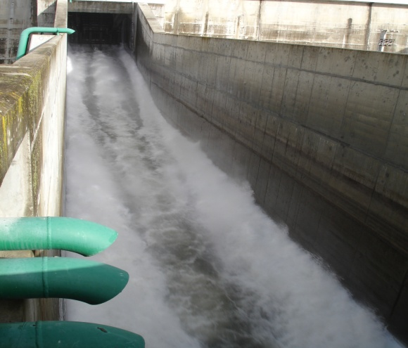 | 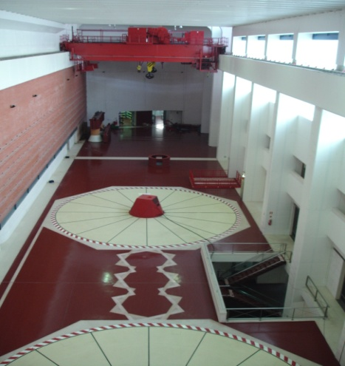

In the afternoon, Raquel Segurado and Sandrina Pereira presented a short introduction to renewable energy sources (RES), where they talked about energy in the past, in the recent past, in the present and in the future. They focused on the energy problem, namely global warming due to energy production related greenhouse emissions and the limitation of fossil fuel reserves. Then, they defined RES and presented it as a potential solution to this problem. They finished with an overview of the European strategy for energy and climate change, the current energy situation in Europe and the last available forecast for the next years until 2030.

Helena Ramos, from the Technical University of Lisbon, presented the fundamentals of hydroelectric energy, and talked more specifically about the use of hydro in water supply systems, referring to available energy assessment and micro-hydro in these systems and pumped-storage optimization of hybrid (hydro-wind) renewable energy production. Helena Ramos was followed by three of her PhD students (Fábio Gonçalves, Mariana Simão and Oreste Fecarotta) that exposed their research in this area.
The day ended with a visit to the Moura Solar Factory, where the assembly of photovoltaic (PV) panels takes place and to the recently inaugurated Laboratory for the certification of PV modules.

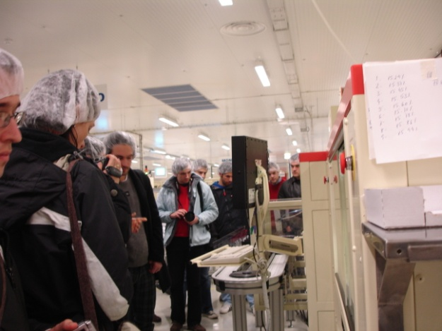 | 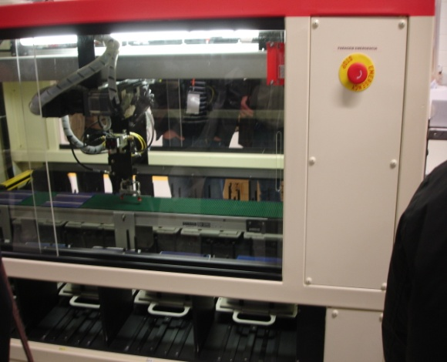

25th February
In the morning there was a visit to the Amareleja Solar PV Power Plant.

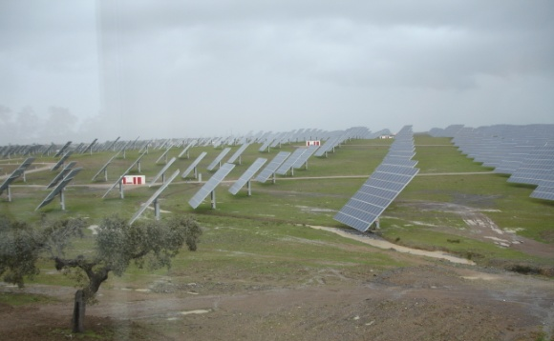 | 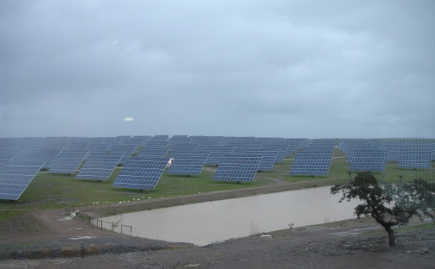

The afternoon was divided into two sessions, one with Ana Estanqueiro about wind energy and the second with António Joyce concerning solar energy, both from the Portuguese National Laboratory on Energy and Geology.
In the first session, Ana Estanqueiro gave an overview of the fundamentals of wind energy, focusing on the technology and resource.
António Joyce session on solar energy started with and introduction to the theme, the solar energy resource, the technologies (solar thermal, solar photovoltaics and concentrated solar power), and ended stating future challenges of this type of energy.

26th February
This day started with a session with Mário Costa, from the Technical University of Lisbon, regarding biomass, starting with a bioenergy overview, going to biomass resources and bioenergy technologies.

Next, Susana Sobral, from the Regional Agency of Alentejo, talked about regional projects for biomass. She mentioned the ALTENER project “Planning the use of Biomass: evaluation of the biomass potential in three European regions: Alentejo (Portugal), Jaén (Spain), Como (Italy)” and a technical project for a pellet plant in Alentejo, with residues from olive and vineyards pruning residues.

In the afternoon, Susana Martins, from ADRIMAG (Association for Rural Development of the Montemuro, Arada and Gralheira Mountains) presented the project CRER (Business Creation Support Methodology) and the initiative ERASMUS for young entrepreneurs.

The last session of this training was dedicated to a roundtable, moderated by Luís Alves from Institute of Mechanical Engineering – IST, were the students could give their opinion regarding the training, if it was interesting, useful and to point out its positive and negative aspects. The students were also asked to mention their future prospects, if they intended to create a company and/or to develop work in the RES area.
This discussion aimed to assess what went right and wrong in this training in Moura, in order to replicate or solve the respective issues in time for the training in Sliven.
In the following sections, the comments of the students that agreed to speak out are exposed.

Harry Stulemeijer (Netherlands)
- Very satisfied with the contents of the training that he considered very comprehensible;
- Learned a lot of things, but there were too much information;
- The sessions should be shorter and with more intervals, maybe 45 minute sessions with 15 minutes break, and the sessions should end at 5 o’clock;
- Harry works in Quinta Essência Soc. Agr. Lda, in Portel, in the production of aromatherapy and medicinal plants, biocosmetics and fytotherapeutics.

George Wandrille (France)
- Very interesting training;
- Opportunity to exchange views;
- It should be more focus on economics;
- It was very useful to have a good overview of all of the technologies;
- George talked about his work on the creation of a network of distributors of RES equipments, being one of the objectives the effort to find a way to reduce fixed costs (advertising, transportation, etc.)

Zahi Dib (France)
- Wonderful opportunity;
- Missing some experience of entrepreneurs that have overcome the difficulties of creating a company and could shared that experience with the students;
- Shared experiences with other students – network;
- Zahi works on buildings, with the objective to reduce their energy consumption, he is on the first stage of creating a business.

Michelangelo Serra (Italy)
- Very nice experience;
- Remarks: entrepreneurship should be more about RES and not so general;
- Very nice technological part but not so much about feasibility, costs, etc.
- Michelangelo is an architect that wants to improve its business with RES, he said that there is a good market for integrated solar system in Italy – there are government incentives but there is lot of red tape.

Rita Paleta (Portugal)
- Remarks: specific analysis on economics of renewable energy systems companies or people to talk about their experience;
- Very good academic point of view, but business point of view was not very stressed;
- Rita is a PhD student and wants to work on microgeneration systems.

Vesselin Chobanov (Bulgaria)
- Very interesting course;
- Vesselin is working on the installation of a PV system in an industrial building in Bulgaria.

Final Remarks
The main conclusions were that the students liked the training and were grateful for the opportunity to form a network among them, but they missed the opportunity to discuss with entrepreneurs.
The students were informed that the professors present in this training, as well as the people from the organisation, are available to stay in touch and respond to any doubts they might have. They were also told that they can have access to the presentations that will be given in the training in Sliven in July.

Participants
In the following table, the name and country of each attendee of this training is stated.

 | Name | Country
1 | Vitor Machado | PT
2 | Rita Paleta | PT
3 | Nuno Teixeira | PT
4 | José Miguel Martins | PT
5 | João Rodrigues | PT
6 | João Fonseca | PT
7 | João Figueiredo | PT
8 | Filipe Coelho | PT
9 | David Maloney | UK
10 | Christopher Pye | UK
11 | Susann Klatte | UK
12 | Jayne Carrick | UK
13 | Neven Krustev | BG
14 | Vesselin Chobanov | BG
15 | Ivan Aleksiev Karavelov | BG
16 | Elitsa Nancheva Naneva | BG
17 | Radek Sedlačík | CZ
18 | Jan Vidomus | CZ
19 | Petra Nezdarová | CZ
20 | Robert Krainer | CZ
21 | Zahi Dib | FR
22 | Chibunna Onyems Igwe | FR
23 | George Wandrille | FR
24 | Arnaud Goussebaile | FR
25 | Ander Badiola | ES
26 | Michelangelo Serra | IT
27 | Armando Riccardo Gaeta | IT
28 | Lavinia Di Francesco | IT
29 | Harry Stulemeijer | NL
30 | António Gato | PT
31 | Alexandra Raposo | PT
32 | José Nobre | PT
33 | Miguel Relva | PT
34 | Valter Rodrigues | PT
35 | Pedro Martins | PT

The first 28 attendees correspond to the one selected and financed by the SUNFLOWER project partners. The next 7 attendees came to the training at their own expense.

