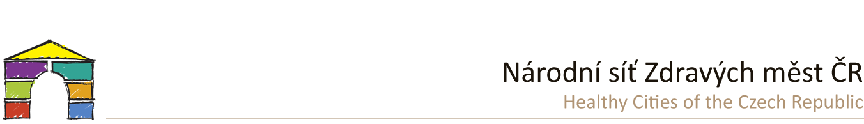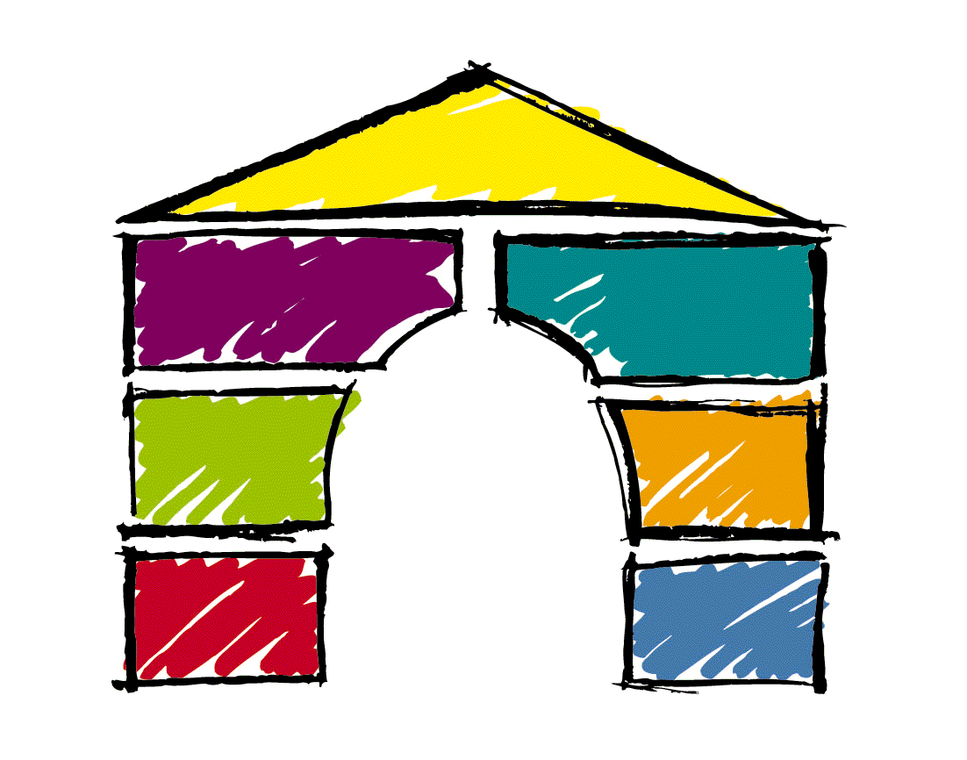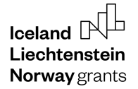

PRESS RELEASE

**Cooperation between Czech and Norwegian**

**cities brought lots of inspiration**

**30. 4. 2024 / For almost two years, city representatives from both countries have shared examples of how to engage the public. A series of planning events, workshops, conferences, and training have taken place. There is much to build on and inspire each other.**

At the end of April, the project of the National Network of Healthy Cities of the Czech Republic, called   
"PART-NET - PARTiciation and NETworking", which was supported by the EEA Grants 2014-2021, was completed. The project aimed to help cities and regions to introduce new participatory methods and innovative ways of engaging citizens. The project partners included the **Norwegian Healthy Cities Network Fremsam** and the Czech cities of **Chrudim**, **Litoměřice**, **Prachatice** and **Valašské Meziříčí**, as well as the **Volunteer Centre Ústí nad Labem**.

During the two-year project, over **20 planning events** with the public in Czechia were organised - forums and roundtables on specific sites that need to be prepared or improved, or topics to be developed in the cities. Cities focused on working with *specific groups of inhabitants such as the disabled* (examples of good practice from *Prachatice*), *seniors* (*Valašské Meziříčí*), *women (Chrudim)*, etc. We paid special attention to planning with *children and youth*. Representatives of towns and schools joined forces and launched a series of activities to involve young people more in public life. The school forums, which were organised by representatives of cities and schools joined forces and launched a series of activities to involve young people more in public life. The school forums, of which there have been **20 in the project**, are not discussions on pre-prepared topics or documents. Their aim is to get the widest possible feedback from children and young people, suggestions for improving the school in question, but especially their town or village - the place where they live or commute to school. In **15** municipalities, so-called "**emotional maps**" have been carried out, where suggestions and information from citizens are recorded over a specific map of a given location or subsequently on an online map, where they feel/do not feel safe, which place to improve, what to modify, etc.

Apart from specific planning actions, the aim was to share inspirations, information - what is working and what is not working. Thus, in the two-year project, **14 national events** - seminars, workshops and conferences - were held in Czechia. Officials and politicians were trained in **5 training programmes** - how to facilitate, how to conduct public hearings, how to communicate. We have collected **16 good practices** from the Czech Republic and Norway, which are continuously presented at home and abroad. These and many other examples can be found in our database [www.DobraPraxe.cz](http://www.DobraPraxe.cz).

Last but not least, there were **2 study trips** organized– in Norway we were able to visit a number of places in three days and discuss community centres, tools for public engagement, and how strategic planning works at the level of Norwegian cities. Seven representatives from Norway came to the Czech Republic and, in addition to concrete examples in Brno, where they discussed participatory budgeting, shared senior housing and other topics, they presented their approaches at a seminar in Prague.

*"Meeting people from other countries who are working on the same goals gives us what I would call a real boost of energy and reminds us of the importance of the European Healthy Cities network. We need to share good ideas and examples so that together we can develop our society." adds Vigdis Holm, Director of the Norwegian National Healthy Cities Network.*

The PART-NET project has significantly contributed to strengthening cooperation between Czech and Norwegian cities and municipalities and to enriching their experience in the field of citizen participation, and we believe that this cooperation will continue to develop. We are confident that this cooperation will continue to develop, not only between the two countries but also with other cities and networks from the European WHO Healthy City Programme.





